Entry form

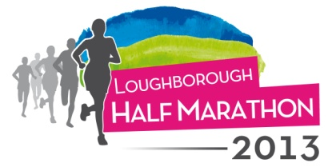

ENTRY FEE: £19.00 AFFILIATED
£21.00 NON AFFILIATED

FIRST NAME: …………………………… SURNAME: ………………………………………
ADDRESS: …………………………………………………………………………………………………………………………………
………………………………………………………………………………………………………………………………………………….
POSTCODE: …………………………….. PHONE NUMBER: …………………………….
EMAIL: …………………………………………………………………………….
DATE OF BIRTH: ………………………. AGE ON RACE DAY: ……………..............
MALE/FEMALE
AFFILIATED YES/NO IF YES CLUB NAME: ……………………………….. EST FINISH TIME:…………………….

I WOULD LIKE TO RAISE FUNDS FOR - LIVING WITHOUT ABUSE OFFICIAL RACE CHARITY:
YES/NO [please circle]

Wheelchair entrants please advise at time of entering

PAYMENT IS BY CHEQUE OR POSTAL ORDER MADE PAYABLE TO: LIVING WITHOUT ABUSE

By submitting this form I undertake to complete sufficient training. I am medically fit and have consulted my doctor with any concerns regarding my ability to race. I understand the race course will be marshalled for 3 ½ hours, after this time LWA and race organisers, marshals or volunteers take no responsibility for any competitors still on the route. All course and medical facilities will cease. I have read and do accept the terms and conditions for this race on the website.
SIGNED: ………………………………………… DATE: …………….

Please complete and send form to:
LWA P O Box 16 Loughborough Leics LE11 3AX

Event numbers, chip timing etc. will be sent to you approximately 14 days prior to race day.

ALL PROFITS FROM THIS EVENT WILL GO TO THE OFFICIAL RACE CHARITY – LIVING WITHOUT ABUSE
www.lwa.org.uk

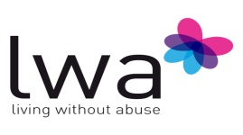

Charity number: 1121923

