Notts Athletic Club Race No.

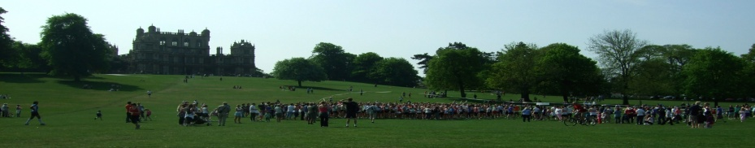
Sponsored by:

Monday 1st April 2013, Start 11.00am
Wollaton Park, Nottingham
Open to runners / joggers of all abilities
Licence number 2013-105214
2 Lap traffic free course in the beautiful grounds of Wollaton Park, Nottingham.
The course is a combination of undulating parkland and tarmac paths.

Commemorative souvenir race mug to all finishers
(2km Family Fun Run 10.00am)

Surname:.............................. First Name:........................... D.O.B................ Age:....... M/F

Address:.................................................................................................................................

Affiliated Club:................................................ UKA Registration No.....................................

Email:............................................................. Telephone No................................................

10km Entry fee £9 affiliated club member. Unaffiliated £11
10k Minimum age for entries is 16 years on race day.

(Entries on the day £2 extra) (Closing date for postal entries 24th March)
Cheques should be made payable to: “Notts 5”
Please enclose S.A.E. 9” x 6” for race number and further details.

Declaration
I declare that the information given on this form is correct.
I agree not to hold the promoter / promoting body responsible in any way for injury or loss as a result of my participation in the race.

Signed...................................................... Date..................................

Entries should be sent to: Notts 10k, c/o Promotional Displays,
Canterbury Mill, Canterbury Road, Radford, Nottingham, NG8 1PQ

